DBT

- Data built tool
- Primarily handles the T in ELT
- Allows easy switching between warehouses
- Provides SQL collaboration
  - Defines data models and transformations using SQL
  - Can define relationships between data models
- Runs the data transformation processes
- Can test for data quality requirements
- Open-source (dbt-core) - dbt-cloud

Purpose: used to transform data in warehouse
Used by: data analyst, engineers, analytics engineer

What is a dbt project:

- Encompass components for working with data in dbt
  - Project configuration
  - Data source and destinations
  - SQL queries
  - Templates
  - Documentations for data and relationship
- Implemented as a folder structure
- Command: db init
  - Can define warehouse, local would be duckdb

Defining configuration with project profiles:

- Profiles
  - Development
  - Staging / testing
  - Production
- A dbt project can have multiple profiles
- Defines in profiles.yml file
- Use dev with duckdb to test locally
- Prod can use snowflake etc

YAML: indentation is important

Duckdb: open-source, serverless database - designed for analytics, vectorized meaning Fast, easy to use

–

Working with dbt projects:

- Dbt init
- Define configs profiles.yml
- Create / use models / templates
- Instantiate models (dbt run)
- Verify / test / troubleshoot
- Repeat as needed

Dbt run:

- Performs transformations and pushes to warehouse
- Run whenever the model changes
- Or when the data process needs to be materialised
- Output providers many details on the success or failure of various steps

Table vs view

Table:
- objects within a database / warehouse that hold data
- Take up space within the database
- Content only updated when changed

Views:
- Queryable like a table; holds no information - take b little space within the database itself.
- Are usually defined as a select query against another table or tables
- Content generated with each query

Dbt supports both depends on configuration. Implementations of these depends on database in Question.

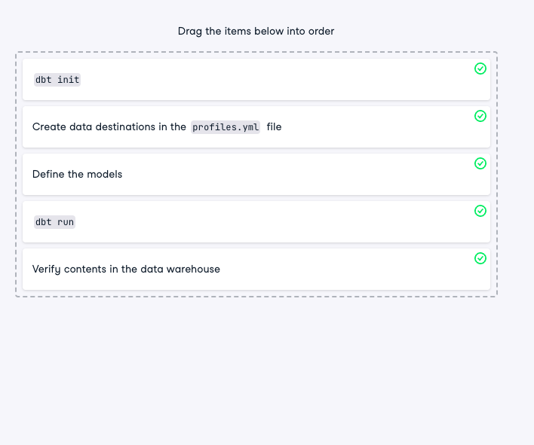

What is a parquet file

–

What is a dbt model:

Data model:
- Logical organisation and interpretation of a dataset
  - Can be table or dataframe, customer orders, etc
- How set of data relate to each other
- Helps users collaborate and understand data in a common way

Model In dbt:
- It represents vbarious tarnsofrmaiton performed on dataset
- Written in SQL
- Newwer versions can use Python
- Usualy a select query
- Each model represent by atext file with .sql extension

Simple dbt model
- Create a directory under models directory - can be anything
- models/order
  - models/order/customer_orders.sql
  - Add SQL statement to newly created file
  - Dbt run to materilize the model

Reading from parquet:
- Columnar binary file format
- DUctDB can read parquet fikes directory
- Select * FROM read_parquet
- Select * from ‘filename.parquet

Updating DBT model:

- dbt to easily change to project without writing new queries or model from scratch
- Why update:
  - Iterative work
  - Fixing bugs within queries / models
  - Migrating to different sources and destinations
- Update workflow:
  - Check out frm source control
  - Git clone dbt_project
    - Not required but advnateous as allows tracking
  - Find the model in question
  - Update query contents
  - Regenerate with
    - dbt run
    - Dbt run -f (force full refresh)
  - Chec changes back to source control
  - Some updates nay require .yml
    - Dbt_project.yml
      - Settings for full project name / version and directory locations
      - Model materilisations settings (global)
      - Only one of this
    - Model_properties.yml
      - Description
      - Docs details
      - Much more
      - It can be named anything as long as exists within model directory

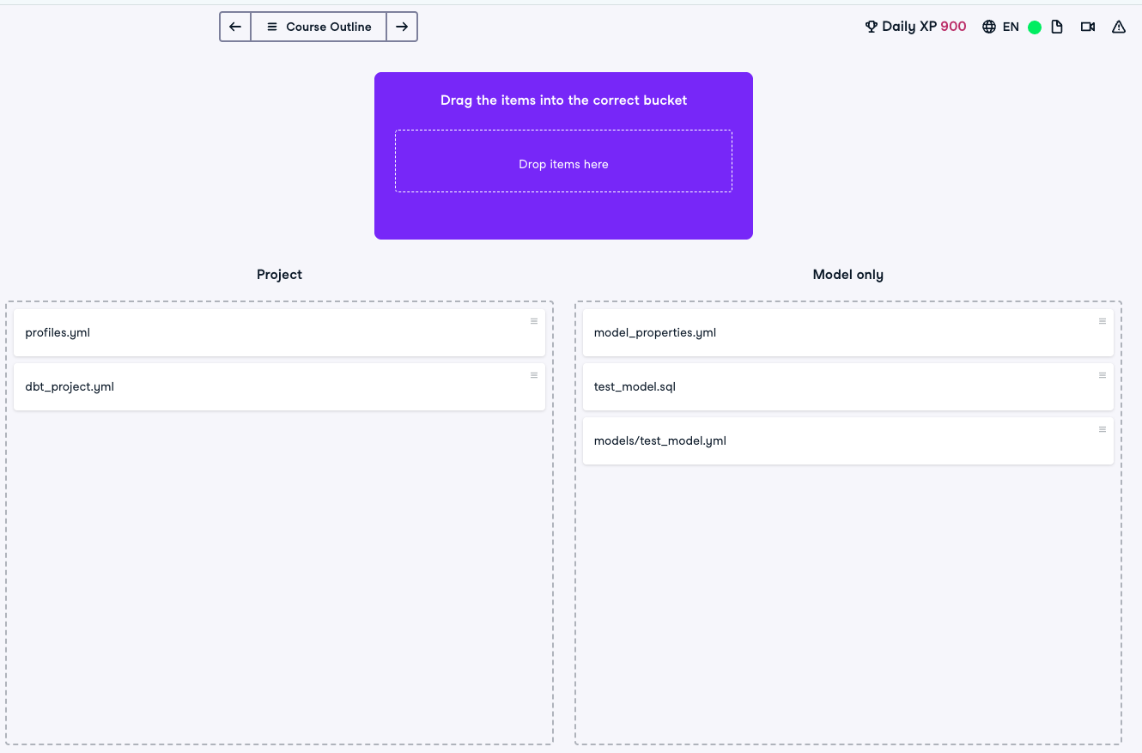

Creating and generating dbt documentation:

- Why document:
  - Sharing details with other consumers
  - Data projects have alot of onsumers
  - Not everyone can be given access to version / source code
  - Centrailise sources of documentation
  - Far easier to have docs on known locations
  - Providing details for updates / changes / etc
  - Creating examples, suggestions for use, SLA details
- Can providers docs with model definitions
- Can add docs about columns within models
- Automatically show data lineage / DAG
- Document any test / validations
- View generated warehouse info:
  - Column data type
- Dbt docs
  - Dbt docs -h — all commands available
  - Dbt docs generate
  - Create the docs website based on project - static website
  - Should be run after dbt run
  - Access docs via web browser and should be hosted
  - Dbt docs serve starts a web server on local system
    - Should be used locally for dev - does not have security
  - Dbt cloud
    - Amazon s3, apache etc
  - 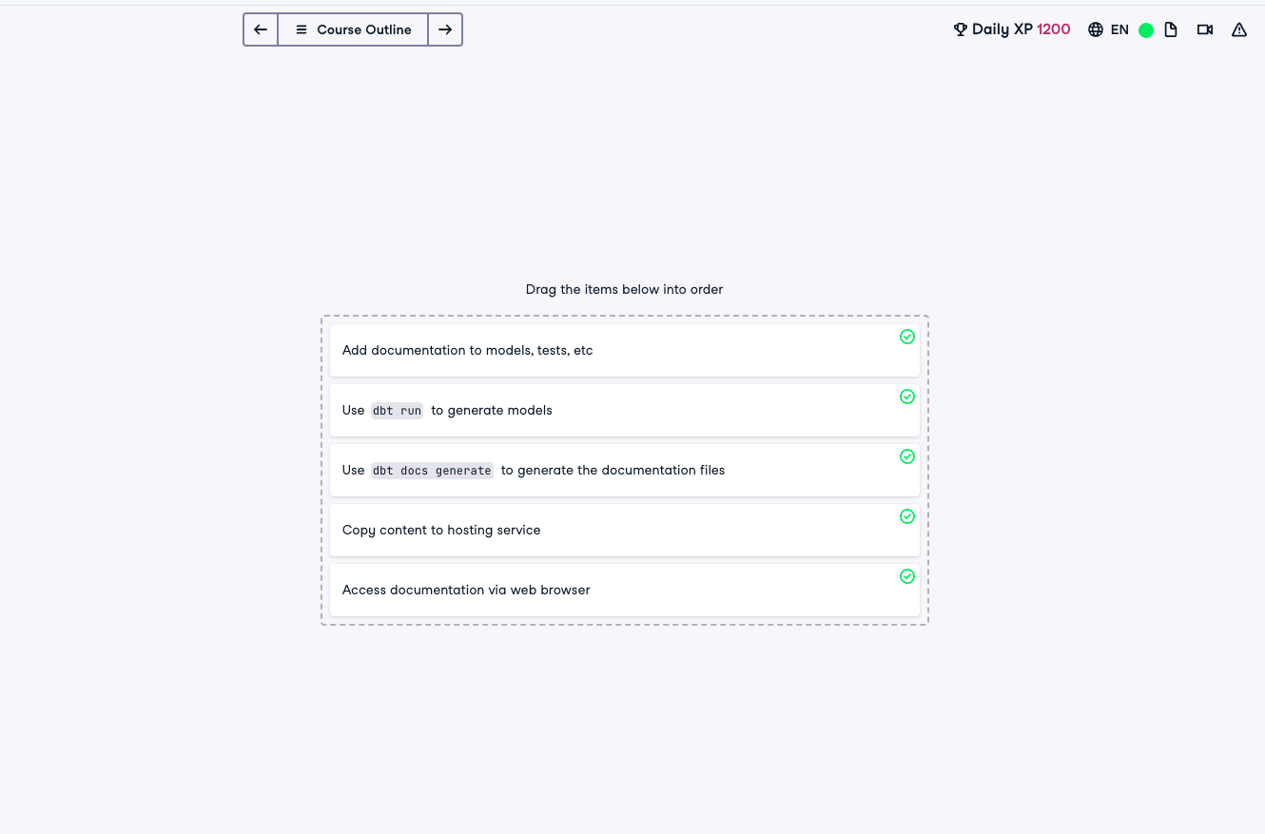

Jinja templates

- Simply creation of models / objectics
- Template: A defined format allowsing for substitution of information
  - Often a text file
- What is jinja
  - Simple text based templating language
  - Used in django, flask
  - {{ … }} represent a template susbitiuon
  - Dbt has many jinja functions for use
  - Allows dynamic usage of dbt
  - Can use for loops to simplify code
- Dbt jinja functions
  - Ref: access models by name
  - Config: access confgi settings
  - Docs: access docs
  - Other: calculationss etc

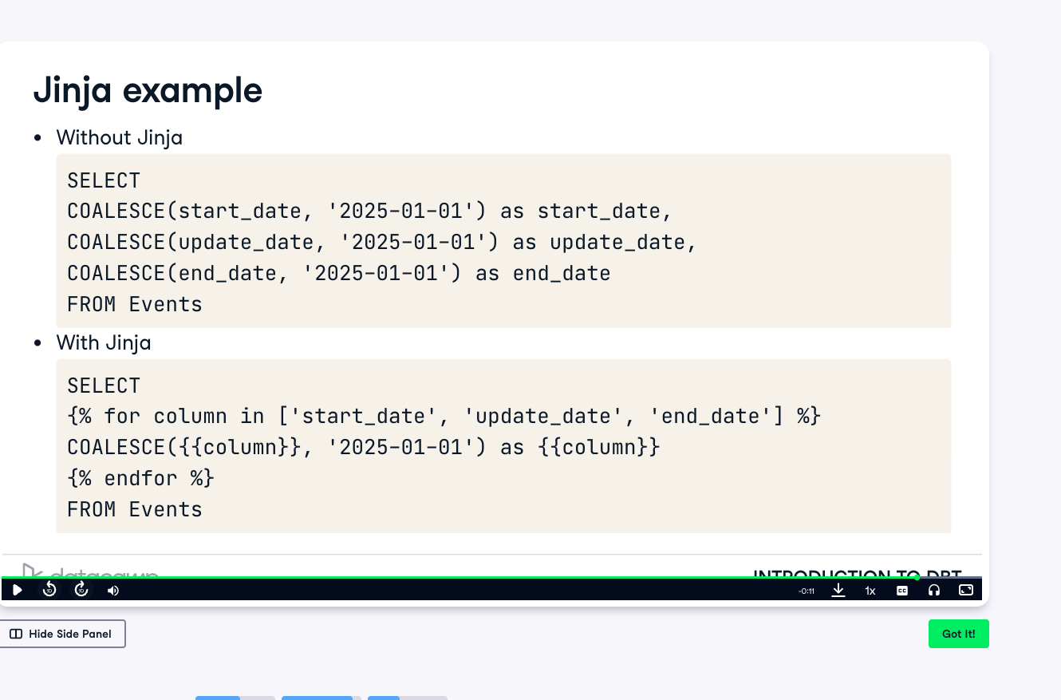

Hierarchical models in dbt:

- Hierarchical in dbt:
  - Represents dependency within a dbt project
  - Also known as DAG
  - Allows modes to be built / updated according to dependencies
- How are defined:
  - Use jinja templates language in model files
  - Most often using ref function
  - Replace table name with {{ref(‘model_name’) }} in SQL
  - Dbt run - materialise the models
- Issues if using table name and the table has not been created yet
  - Better ot use ref(‘table_name’)
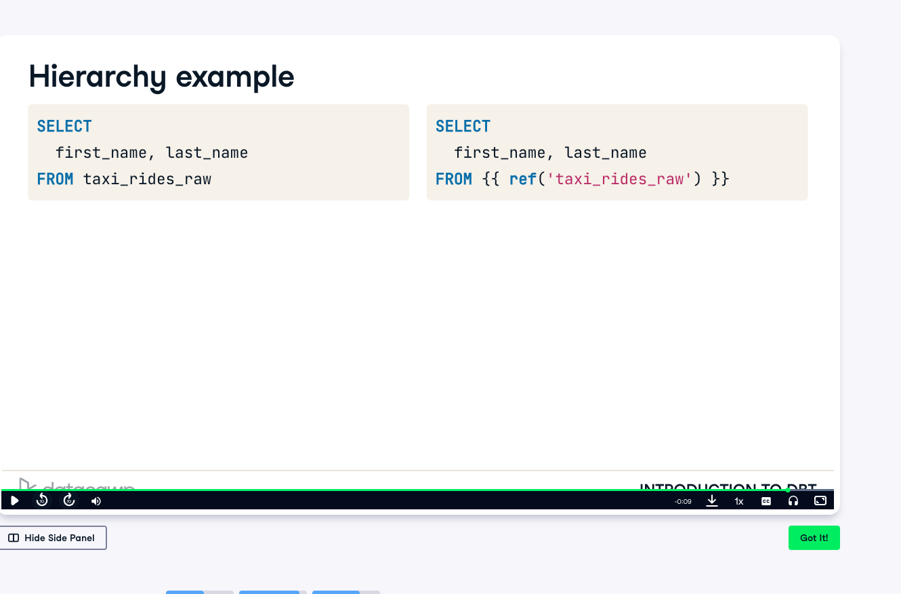

- Best practices for dependency management in models:Use ref function to handle model relationships
  - Avoid direct table references to prevent failure

Docker

Docker run

Docker run -it ubuntu

- Gives us access to the machine via terminal

Docker run -d postgres

- Runs the container in the background without printing the output to the shell

Docker ps

- Allows us to see any running container

Docker stop

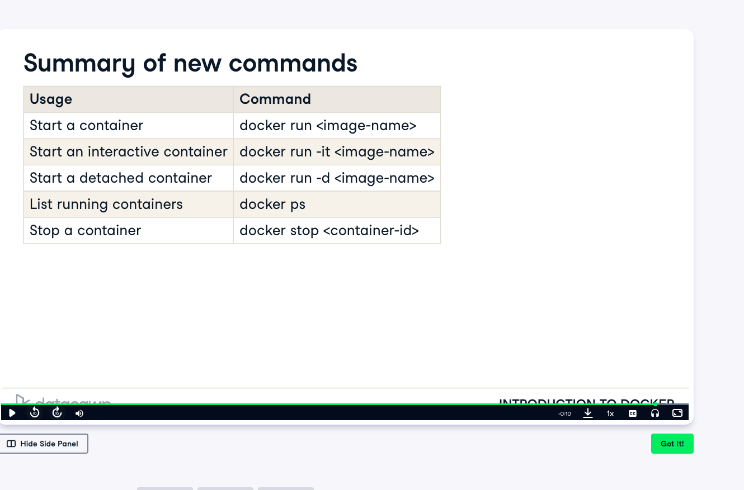

Working with docker containers:

Listing : docker ps
Lots of containers are a problem

Docker run –name <containername> <imagenname>
Docker ps -f “name=<container name>”

Docker logs <container id>
- Debug issues

Docker logs -f <container-id>

Docker container rm <container-id>



